Supervised Learning Techniques

Naïve-Bayes Classiﬁcation

The Naive-Bayes classification model is a learning model that uses Bayes Theorem in its underlying working. Hence it is very simple, easy to understand and to implement. Naive Bayes classifiers are highly scalable, requiring a number of parameters linear in the number of variables (features/predictors) in a learning problem.
It works under the assumption that each feature is conditionally independent of the remaining.
For textual based classification we split the document into bag-of-words and then consider them independently there by ignoring the position of the words.

This classification technique is based on Bayes Theorem to predict the probability that the test data point with the given feature set belongs to particular class.

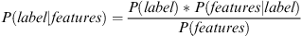
P(label) is the prior probability of a label or the likelihood that a random feature set the label.
P(features|label) is the prior probability that a given feature set is being classified as a label.
P(features) is the prior probability that a given feature set is occurred

Classification using Maximum Entropy

Principle of Maximum Entropy – Consider the testable information about a probability distribution function. Examine all the probability distribution that would satisfy the testable information. Of those examined distributions, the one with maximum entropy is the proper distribution.

Entropy – Entropy is the as the negative of the logarithm of the probability distribution.

The Maximum Entropy is based on the principle of maximum entropy and of all the models that fits our training data it selects the one with the largest entropy.
Maximum Entropy model does not assume that the features are conditionally independent of each other and is normally used to solve many text classification problems such as language detection during translation.

In this technique we encode the given feature set and for each of this encoded vector we calculate weights such that this weight can be used to determine the most likely label for a given feature set.

Probability of each label for a given feature set is then calculated using below formula. [something]

Support Vector Machines (SVM)

They are often called the large margin classifiers because, given a set of training data such that each point is marked belonging to one of the two possible categories, an SVM algorithm builds a model such that it assigns its own new examples into one category so as separate the categories by a clear gap that is as wide as possible.

The main principle of SVMs is to determine linear separators in the search space which can best separate the different classes. Textual data are ideal for SVM classification due to high dimensionality and thereby sparse nature of the data with many irrelevant features. Hence, SVM can construct a non linear decision surface in the original feature space by mapping the data instances non-linearly to an inner product space where the classes can be separated linearly with a hyperplane. [something]

By separating classes during the training stage with the examples generated on its own, we can obtain much higher accuracy during the testing stage.
However, SVM is only restricted to classifying binary problems but we can still classify multiple class problems by dividing the problem recursively into binary problems.

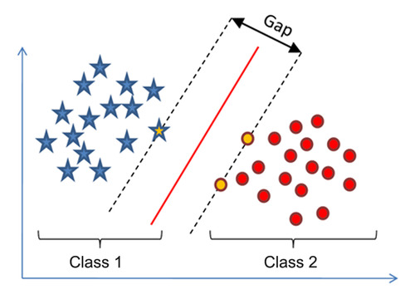

Decision tree classifiers

Decision tree classifier provides a hierarchical decomposition of the training data space in which a condition on the attribute value is used to divide the data [76] of [something].

The condition or predicate is the presence or absence of one or more words. The division of the data space is done recursively until the leaf nodes contain certain minimum numbers of records which are used for the purpose of classification. [something]

There are many ways of splitting the data including Single Feature Split where a presence or absence of a single word or phrase determine the split.
Similarity-based Multiple Feature Split [something] uses a set of frequent words or phrases or similarity between the words present in the document with that of the test condition.

